
Taking the Mystery Out of Chart Setup and Trading Psychology
Let me tell you straight - there's no magic system that'll make you rich overnight. But what I can share is a solid approach that combines traditional trading wisdom with some clever modern tech. Think of AIT as having an experienced trader looking over your shoulder, but one who can process information faster than any human.
The AI has been trained on the following Technical Indicators which are free on both TradingView and the eToro ProCharts TradingView adaptation.
- EMA 21 (light blue) - This is your primary trend spotter
- EMA 50 (dark blue) - Your bigger picture guide
- MA/EMA Cross 10/10 - These crosses can be golden
- DMI - Directional Movement Index
- MACD – Moving Average Convergence/Divergence
- Stochastic RSI
- ATR – Average True Range.
Getting Your Charts Right
First things first - let's get your charts set up properly. I always tell people that your charts are like your trading cockpit. You wouldn't try to fly a plane with half the dials missing, would you?
Here's what you need:
The Moving Average Magic
I love my moving averages - they're like having a sat nav for trading. Get these on your chart:
- EMA 21 (light blue) - This is your primary trend spotter
- EMA 50 (dark blue) - Your bigger picture guide
- MA/EMA Cross 10/10 - These crosses can be golden
The Ichimoku Cloud
Don't let the fancy name scare you. Once you get used to it, it's brilliant. Set it up with:
- Conversion Line Period 9,
- Baseline Periods 26,
- Leading Span Periods 52
- Lagging and Leading Periods (26,26
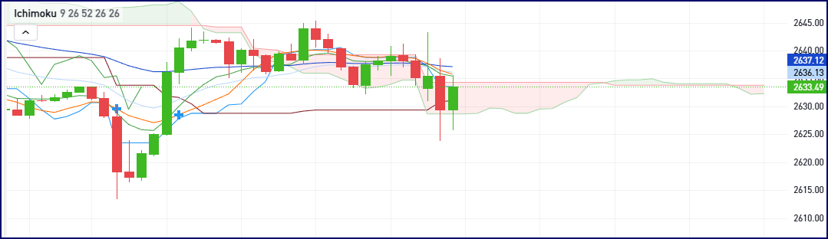
The Ichimoku Cloud is like having a complete weather map for your trading - it might look complicated at first with all its lines and shaded areas, but it's actually brilliant once you get used to it. You'll see a cloud-like shape (usually coloured red and green) floating across your chart - this is created by two lines plotting potential future support and resistance.
Above and below this cloud, you've got the faster-moving Conversion line (Tenkan-sen) and Base line (Kijun-sen) that dance around price like synchronised swimmers, while the Lagging Span line trails behind price like a shadow, helping confirm the overall trend.
When price is above the cloud, you're in sunny bullish weather; when it's below, it's bearish rain; and when price is inside the cloud, it's like being in fog - best to wait for clearer conditions.
This Ichimoku Cloud setup above is telling a bearish story. We've got price breaking below the cloud with the cloud itself turning red ahead - that's a classic bearish signal. The Conversion line (blue) crossing below the Base line (red) adds confirmation to the downside pressure.
While price is finding some temporary support, the cloud above is now resistance and its widening boundaries suggest increasing bearish momentum. The overall message from the cloud is clear - conditions are turning bearish and any long positions would need strong justification.
MACD (Moving Average Convergence Divergence) is like having a speedometer for price momentum.
- The MACD line (blue) is your fast line - it's quick to react to price changes. Think of it as your sports car that can accelerate and brake quickly.
- The Signal line (orange) is your slow line - it takes its time. It's more like a steady family car that doesn't rush anywhere.
- The histogram bars in the middle show you the difference between these two lines - the bigger the bars, the stronger the momentum.
What the AI is trained to “look for”:
When the blue line crosses above the orange, that's potentially bullish. When it crosses below, that could be bearish. But here's the real gem - look for divergence. That's when price makes a higher high but MACD makes a lower high. It's like watching an athlete who's running out of steam - they're still moving forward but slowing down.
Settings: I keep it simple with the standard 12,26,9 - that's worked well for years, so why mess with it?
Remember though - MACD is a lagging indicator. It's confirming what's already happened rather than predicting the future. That's why we use it alongside other indicators for confirmation.
Pro Tip: When MACD crosses line up with other indicators (like DMI crosses or Stoch RSI signals), that's when things get interesting. Those are the setups worth having a proper look at.
DMI (Directional Movement Index)
Think of DMI as your trend strength meter. It's like having a weather vane that shows you both the direction and strength of the wind. You've got three lines to watch:
- +DI (Blue Line): Shows bullish pressure
- -DI (Orange Line): Shows bearish pressure
- ADX (Pink Line): Shows overall trend strength (regardless of direction)
- For clarity we disable the DX and ADXR lines so as not to confuse the AI
- For further clarity, draw a horizontal line with a value of 25.
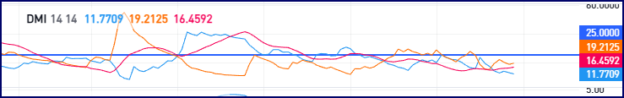
What to Look For:
When the +DI crosses above the -DI, that's bullish. When it crosses below, that's bearish. But here's the key - look at that ADX line. If it's above 25, the trend is strong. Above 40? That's a really strong trend you might want to jump on. Below 20? The market's probably chopping around like a drunk sailor - best to stay out.
These are your trend strength meters. They help keep you out of trouble when the market's being choppy.
Stochastic RSI.
I absolutely love this indicator for spotting potential reversals before they happen. Think of it as your market thermometer - when things get too hot or too cold, something usually gives.
Set it up like this:
- Length: 14
- RSI Length: 14
- Stochastic Length: 3
- Smoothing: 3
What's brilliant about the Stoch RSI is it gives you heads up about potential reversals when you get readings above 80 (overbought) or below 20 (oversold). But here's the thing - don't just dive in the moment you see these levels! I've learned the hard way that you need confirmation from your other indicators.
We use it as part of our 'weight of evidence' approach. When the AI “sees” the Stoch RSI getting extreme, it cross-references to the EMAs and Ichimoku setup. If they're all telling the same story, that's when things get interesting.
Pro tip: Look for divergence between price and the Stoch RSI - that's when price makes a new high but the Stoch RSI makes a lower high, or vice versa. That's often a lovely early warning signal that the trend might be running out of steam.
ATR - Average True Range
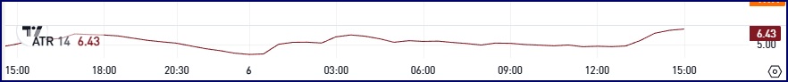
The Average True Range (ATR) is your market volatility thermometer - it tells you how wild prices are swinging. We use it with a 14-period setting, and it measures the average range between highs and lows including any gaps between closing and opening prices.
What's brilliant about ATR is it helps you set sensible stop losses - in a volatile market with a high ATR, you need to give your trades more room to breathe, while in quiet times with a low ATR, you can keep your stops tighter. Think of it like deciding how much space to give the car in front when you're driving - in bad weather (high ATR), you need more stopping distance!
Pro Tip: A really handy rule of thumb is to set your stop loss at 1.5 to 2 times the current ATR value. That way you're not getting stopped out by normal market noise but still protecting your capital if things go wrong.

Making Sense of Fibonacci - Your Roadmap for Retracements
Let me tell you about one of my favourite tools - the Fibonacci retracement. We use this beauty on the 1-hour timeframe, and there's a good reason for that. Fibonacci levels are all about finding those natural pause points in price movement, and the 1-hour chart gives you the sweet spot between noise and significance.
Drawing Your Fibs Properly
Here's the crucial bit - you need to draw them correctly or they're about as useful as a chocolate teapot.
For an Uptrend:
- Start at the significant low point
- Drag to the recent high
- The tool will automatically give you those magic levels:
  - 23.6%, 38.2%,
  - 50%, (Not a true level, Psychological Level)
  - 61.8%, 78.6%
For a Downtrend:
- Start at the significant high point
- Drag to the recent low
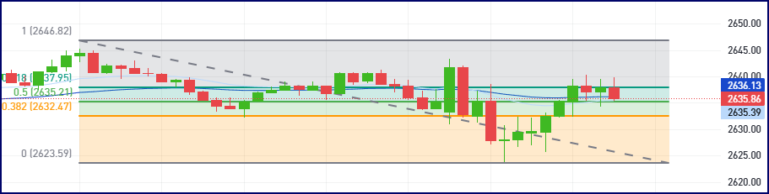
- Same levels appear, but in reverse
The Key Levels to Watch - we only select 0, 0.382, 0.5, 0.618, 1 for absolute clarity
- 38.2% - Often a shallow retracement in a strong trend
- 50% - The psychological halfway point (not actually a Fib number, but works brilliantly)
- 61.8% - The golden ratio, my absolute favourite for major retracements
Why These Work
The beauty of these levels is that they often act as self-fulfilling prophecies. Because so many traders watch them, they become natural support and resistance levels. It's like everyone agreeing to stop at the same petrol station on a long journey.
A Word of Caution
Never, and I mean never, use Fibonacci levels on their own. They're part of your trading toolkit, not the whole toolbox. I always want to see them line up with other indicators - maybe an EMA, or a previous support/resistance level, or a nice candlestick pattern.

AI-Enhanced Analysis over Different Timeframes.
Now, this is important - you need to look at different timeframes like you're zooming in and out with Google Maps. Scroll around to get in the general location, then zoom in to spy on your ex.
- Daily chart - Your big picture view
- 4-hour - Getting closer to the action
- 1-hour - Where the serious stuff happens
- 30-minute - Fine-tuning your timing
- 10-minute - Getting your entry spot-on
The Psychology Bit
Here's the thing - all these fancy indicators won't help if you're trading like a kid in a sweet shop. You need patience. Sometimes the best trade is no trade at all. I can't tell you how many times I've made money by sitting on my hands with a cup of tea and some toast.
The Tech Behind It
We've trained some clever AI to think like an experienced trader. It looks at all these indicators, patterns, and market conditions - just like a seasoned pro would, but it can do it faster and across more timeframes. It's not there to replace your brain - think of it more like having a really switched-on trading buddy.
Risk Management (The Boring But Important Bit)
Never risk more than 1-2% on a trade. I don't care how certain you are - the market loves to humble you just when you're feeling clever. Set your stops, know your targets, and stick to them like they're the last chocolate biscuit in the packet.
Remember, trading isn't about catching every move - it's about catching the good ones and keeping your money safe the rest of the time. This setup helps spot those higher probability trades, but you still need the discipline to wait for them.
The Whole Package
When you put it all together - the chart setup, the multiple timeframes, the risk management, and the AI assistance - you've got a pretty solid approach to trading. It's not going to make you a millionaire overnight (if anyone promises you that, run away fast!), but it might help keep you in the game long enough to become a consistent trader.
Want to know the best bit? When everything lines up - the daily trend, the 4-hour direction, the 1-hour setup, and the shorter timeframe confirmations - it's like having the trading equivalent of a royal flush. Those are the trades you want to be in.
Remember: Keep it simple, stay patient, and never risk what you can't afford to lose. The market will still be there tomorrow, but your capital might not be if you don't respect it.

